

YEAR: 9
SUBJECT: SCIENCE

TEST: Matter
TIME: 50 mins
QUESTIONS: Part A: Multiple Choice Questions (10 marks)
Part B: Short Answer Questions (24 marks)
Part C: Extended Response (5 marks)

TOTAL MARKS: 39 marks

DO NOT WRITE ON OR MARK THIS PAPER

SECTION ONE: Multiple Choice Questions (1 mark each)
Answer this section on the separate multiple – choice answer sheet

- Which of the following statements about atoms is true?
- Neutrons and protons are found in the nucleus with the electrons
- The number of neutrons found in the nucleus of an atom is always the same
- Protons circle the nucleus all the time
- An atom is mostly empty space

- The nucleus of an atom is made up of
- electrons and protons
- protons and neutrons
- neutrons and electrons
- neutrons

- An ion is best defined as: An atom which has

- lost electrons
- gained electrons
- gained or lost electrons
- gained neutrons

- The atomic symbol for a gold atom is 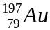. Clarify what this tells you about the gold atom.

- It contains 118 protons.
- It contains a total of 197 protons, neutrons and electrons.
- It contains 118 neutrons.
- It contains 197 electrons.

- What is the electronic configuration of a chlorine atom? Hint: Chlorine has an atomic number of 17.
- 2,2,2,2,2,2,2,2,1
- 2,8,7
- 8, 8, 1
- 2,10,5

- A phosphorus atom has an atomic number of 15. State how many electrons it has in its third (outermost) shell.

- 0
- 2
- 5
- 8

7. A radionuclide is:

- a radioactive isotope.
- a charged atom
- an element that emits beta radiation.
- an atom with the same number of protons but a different number of neutrons.

- The mass number of an atom is the number of

- neutrons in its nucleus.
- electrons in the nucleus.
- protons in the nucleus.
- protons plus neutrons in the nucleus.

- Which of the following will cause an atom to become a negative ion?
- gain electrons.
- lose protons.
- gain neutrons.
- lose neutrons.


- Scientists use the process of decay in radioactive isotopes called to determine the of organisms.

- aging; carbon
- radioactive aging; carbon
- dating; age
- carbon dating; age


SEMESTER ONE 2018
Chemistry Test:
ANSWER BOOKLET
NAME:
FORM: DATE:

Multiple Choice Short Answer Extended Response Total

/10

/24

/39

/5

SECTION ONE: Multiple choice answers
Cross (X) through the correct answer.

1 | a | b | c | d
2 | a | b | c | d
3 | a | b | c | d
4 | a | b | c | d
5 | a | b | c | d
6 | a | b | c | d
7 | a | b | c | d
8 | a | b | c | d
9 | a | b | c | d
10 | a | b | c | d

SECTION TWO: Short Answer (28 marks)
Answer the questions in the spaces provided.

Question 11

Identify the number of protons, neutrons and electrons in the atom of potassium: (3 marks)
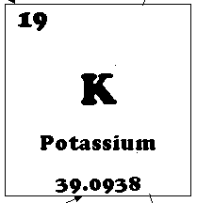

- protons: 19
- neutrons: 20
- electrons: 19

Question 12
For each of the electron configurations below, construct an electron diagram and write the name of the element you have drawn. (8 marks)
(Electron diagram: 1 mark Name of the element: 1mark)
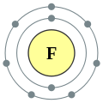
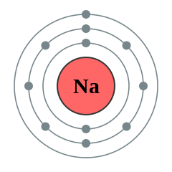
Electron Configuration: 2, 8, 1 Electron Configuration: 2, 7
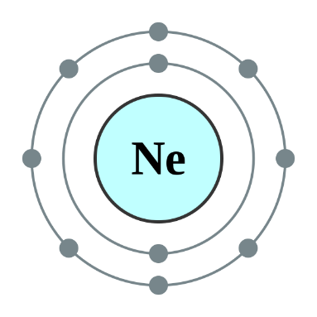
Element: Sodium Element: Fluorine
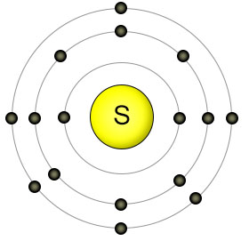

Electron Configuration: 2, 8, 6 Electron Configuration: 2, 8
Element: Sulfur Element: Neon

Question 13
Carbon has different isotopes, as shown in the diagram below.
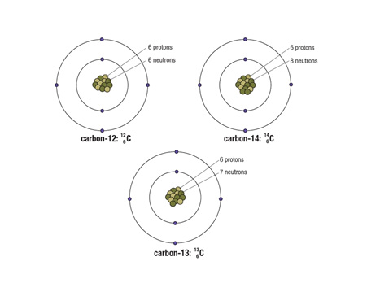
Describe the similarities and differences between these shown. (3 marks)

Similarities Any 2 of the following (1 mark each)
- All of the atoms of carbon have the same atomic number = 6 = number of protons
- All isotopes have same number of electrons
- All of isotopes have same number of shells or orbits
Differences (1mark)
- Each of the atoms is a different isotope of carbon, which means that they have different numbers of neutrons in the nucleus
Question 14
The atoms below are written using the letters V to Z instead of their correct chemical symbols.
  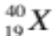 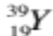 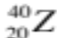 (4 marks)
- Which two atoms have the same number of neutrons?
Y and Z
- Which atom has the smallest mass number?
W
- Which two atoms belong to the same element?
X and Y
- Which atom has the electron configuration 2, 8?
W
Question 15
This paragraph has some missing words. Their positions are numbered. (6 marks)
Ernest (1) proposed a new model for the atom where there is a small positively-charged (2) surrounded by (3) -charged electrons. Later on scientists discovered that there were two types of particles inside the nucleus—positively-charged (4) and neutrons, with no (5) . The number of protons is always the same as the number of (6) .

Which word goes in which position? Choose the correct word from the jumbled list below by writing each one in the correct numbered position:

charge electrons negatively nucleus protons Rutherford

(1) Rutherford
(2) nucleus
(3) negatively
(4) protons
(5) charge
(6) electrons

SECTION THREE: Extended Response (5 marks)
- Select either question ONE or TWO and write the question number in the box below. Answer the question in the space provided. Question 2 has 3 parts to it.
- Explain why oxygen atoms ionise to form the oxide ion with a charge of –2. Identify if oxide is an anion or a cation.
- Some isotopes of the elements are unstable. This means they may undergo decay or change into another isotope and emit certain radiations.
- List three types of radiation in order from least penetrating to most penetrating.
- Compare the (similarities and differences) properties of those radiations. You need to show at least two properties for each radiations.
- What do you mean by the term half-life of a radioactive material?

Question Number: 1

1 mark for each of the following points or similar reasonable response:
- When atoms ionise, only the valence electrons are affected
- Oxygen atoms have an electron configuration of 2, 6 and so have 6 valence electrons
- Outer electron shells are stable when they are full and it is easier to gain two electrons that to lose six, therefore oxygen atoms gain 2 electrons
- Each electron has a charge of -1, so gaining 2 electrons results in an overall charge of -2
- Oxide is a negative ion, so it is an anion
Question Number: 2
- Alpha, Beta and Gamma radiation 1- mark ( wrong order give ½ mark if they wrote names correctly)
b ) Similarities ( Any 1 of the following 1 mark)
- These are all produced by nuclear activity.
- Unstable atoms eject these particles from their nucleus due to nuclear reactions.
- They can damage cells of living organisms.
Differences
Alpha (α) particles (Any two properties ½ mark each. Total: 1 mark)
- An alpha particle is identical to the nucleus of a helium nucleus. It contains two protons and two neutrons.
- Alpha particles are large, heavy and slow (10% of speed of light).
- They can only travel a few centimetres in air and is easily stopped by a thin sheet of paper or dead skin

Beta (β) particles (Any two properties ½ mark each. Total: 1mark)
- Beta particles are identical to electrons and therefore are very small and have a negative charge.
- The beta particles that make up beta radiation are small and fast (90% of speed of light). This means that beta radiation penetrates the skin more deeply than alpha radiation.
- Beta radiation can be blocked by a thin plate of aluminium.

Gamma (γ) radiation (Any two properties ½ mark each. Total: 1 mark)
- Gamma radiation can travel through skin, bone and aluminium, making it extremely dangerous to humans
- A thick layer of concrete or lead can block the radiation
- Gamma radiation is made up of electromagnetic waves rather than particles.
- Gamma rays do not have any mass or charge and travel at the speed of light.

C ) The half-life of a radioactive material is the time taken for half of the radioactive nuclei in a sample to decay. (1 mark)

END OF TEST
Please check your work!

